Surface Water Hydraulics
The purpose of this training module is to teach users how to use EPA-SWMM’s tools to edit a collection system network and develop hydraulic input data. You will learn how to use the various EPA-SWMM Routing methods. Finally, model results will be reviewed graphically and in tabular format.

Objectives
A stormwater collection network can be developed in the graphical interface using a variety of methods. In this example, users will learn how to utilize tools to build on the model started in the Hydrologic Workshop Example using various tools to add data to the model. You will learn how to:
Layout links and nodes
Input ground elevations and inverts
Calculate pipe lengths from the model coordinate system
Enter required data for links and nodes in dialogs
Enter the basic configurations settings for routing
Obtain results from the output file and the Review Results tool

Data files to be used are:
Hydrology.inp
Background.bmp

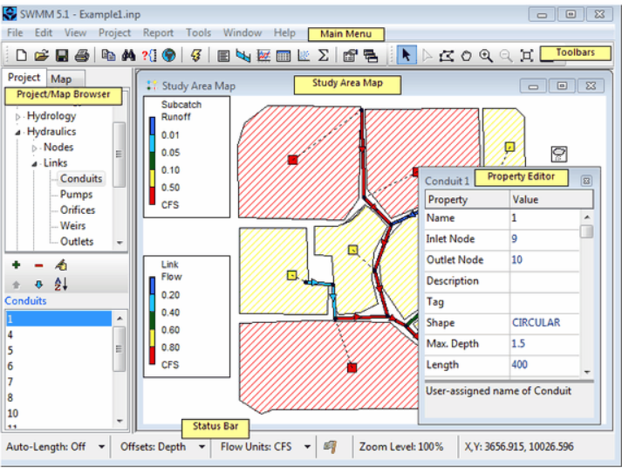
Although this was covered in the Hydrology Example, we are repeating this basic SWMM information here as well. An EPA-SWMM model includes a series of input and output files. The main file is the .inp file that holds the data for the model and references other files needed. SWMM’s main window is shown below along with key elements of the window. The main menu is located across the top of the SWMM main window and includes a group of menus we will be using during the training. Toolbars provide shortcuts to commonly used operations. Project/Map browser provides access to all of the data in a project. The study area map provides a planar schematic diagram of the objects comprising the drainage system. The property editor is used to edit the properties of data objects that can appear on the Study rea Map. It is invoked when one of these objects is selected (either on the Map or in the Project Browser) and double-clicked or when the Project Browser's Edit button edit is clicked. The status bar appears at the bottom of SWMM’s Main Window and is divided into six sections. Please read the help file for additional information on each element.
Open EPA-SWMM and Review Existing Model Data
At the opening dialog, select either the Open an existing project button 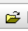 or the Open… under the File pull down menu. In the Windows Explorer, navigate to the Documents\Data\Austin\Hydraulic folder and select the file Hydraulic.inp. The model is shown on the following page.

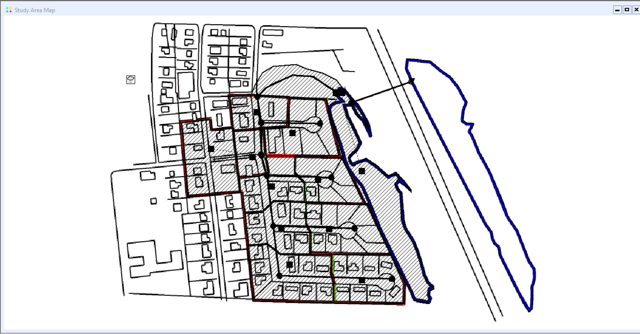
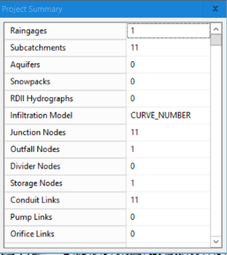
The next step is to review the data in the model. An overview of the data is available by selecting the Project pull-down and choosing Summary. This provides the project summary including the number of subcatchments, nodes, and links as shown to the right.
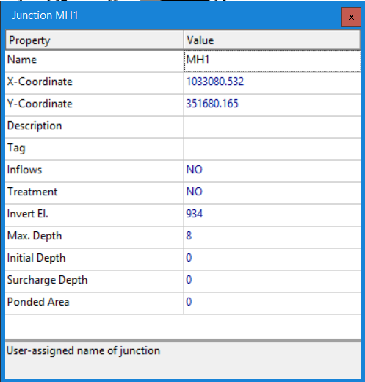
Select the Project pull-down again and then select Details. This shows the user all the data within the model by data category. However, the user can not edit the data. Review the data under Junctions, Outfalls, Storage, conduits, xsections and transects. In the Project/Map Browser, the user can see and edit the data by category. First select junctions in the Project/Map browser, then by selecting the edit button , the user can edit the data in the window to the left. Note that the invert elevation is specified while the rim elevation is shown as Max. Depth and is the invert elevation plus the max. depth (942.0 in MH1). The next step would be to review the general data in the model by walking through all of the Options data. We did that in the previous example. However, we are running both hydrology and hydraulics in this example. By selecting the Options list, a series of simulation options are provided as shown to the right. Only the Rainfall/Runoff Model is active. We will need to check the Flow Routing module so we can rout the runoff trough the links.

Adding an additional node and link
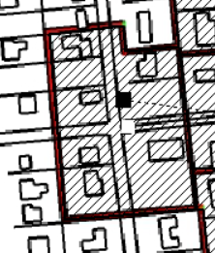
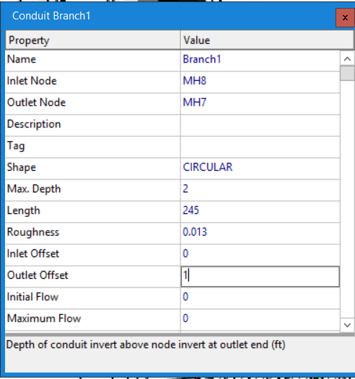
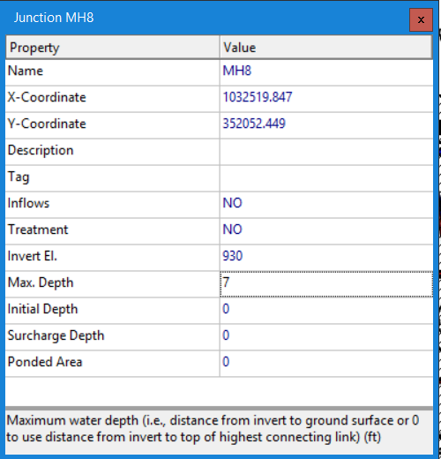
In the Project/Map Browser, select Hydraulics, Nodes, Junctions and then the green plus button. Then click on the drawing to add the junction as shown in the red circle to the left. Then click on the edit object button to add the junction data. Add the data to the right including the Name, Invert El., and Max Depth. Then click on the red x to close the dialog box. Then in the Project/Map Browser select Hydraulics, Links, Conduits and then the green plus button. Single click on Junction MH8 and draw a line to MH7. Then click on the edit object button to add the link data. Add the data to the left including the Name, Length, Roughness, Max Depth and Outlet Offset. Then click on the red x to close the dialog box. Then we need to connect Subcatchment MH7#2 to the new MH8. This is done in the Project/Map Browser by selecting Hydrology and Subcatchment and then the edit object button for subcatchment MH7#2. Then change the outlet from MH7 to MH8.
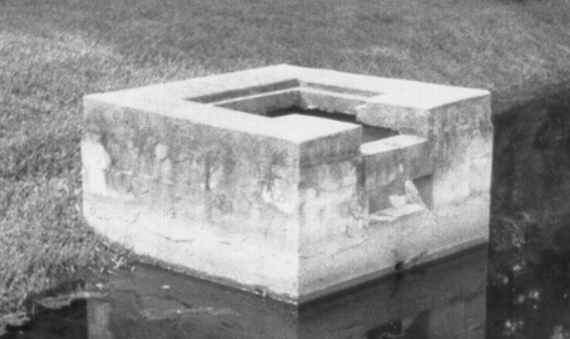
Adding the Pond Outlet Structure Data
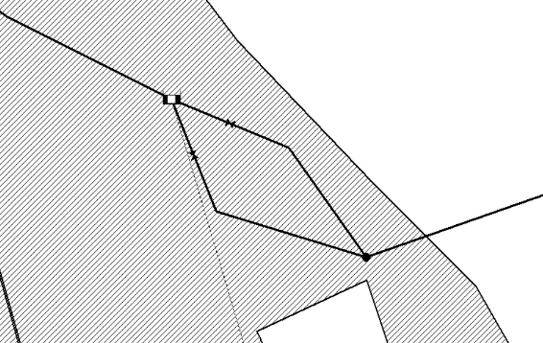
A picture of the structure we will be adding to the model is shown to the right. Note that this structure includes two orifices and two weirs. First, we are going to zoom into the model area around nodes Pond and Riser by using the zoom in on the map button  on the toolbar. In the Project/Map Browser select Hydraulics, Nodes, Storage Units. Then click on the edit object button to review the storage unit data. To add the orifices and weirs, we will need to know some basic information about the storage unit Pond. The invert El. is 920 with a Max. depth of 14 feet. In the Project/Map Browser, select Hydraulics, Links, Orifice and then the green plus button. Then draw two lines from Pond to Riser as shown to the left. Select Orifice 1 and click on the edit object button to edit the orifice data as shown on the following page. Repeat the above for orifice 2 and enter the data shown on the following page.
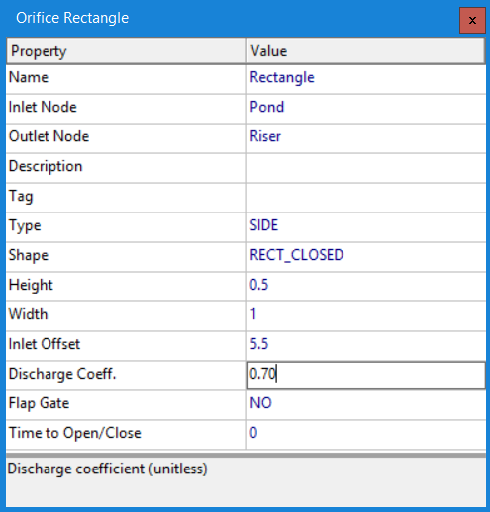
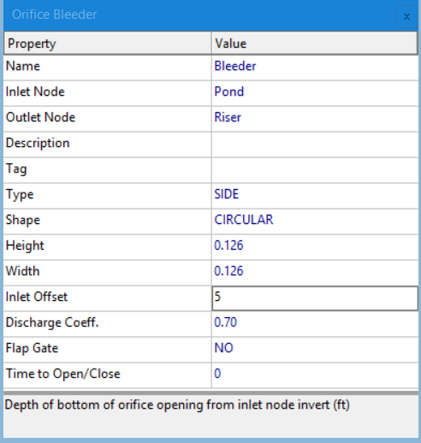
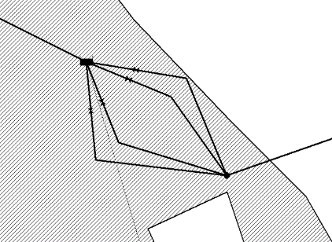
The next step is to add the two weirs to the model. In the Project/Map Browser, select Hydraulics, Links, Weirs and then the green plus button. Then draw two lines from Pond to Riser as shown to the left. Select Weir 1 and click on the edit object button to edit the orifice data as shown on the following page. Repeat the above for weir 2 and enter the data shown below.
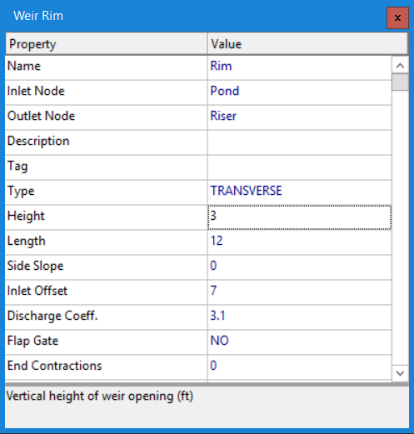
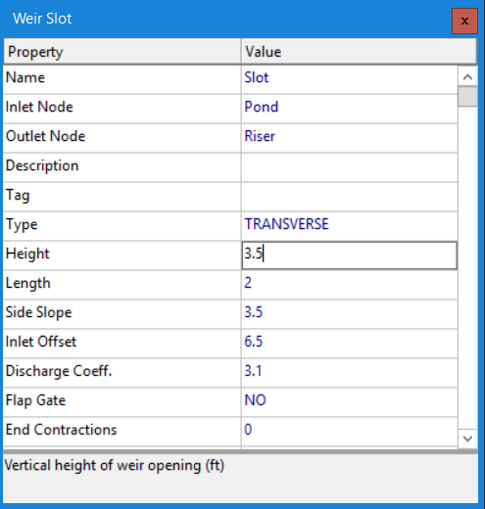

Run the Model and Review Results
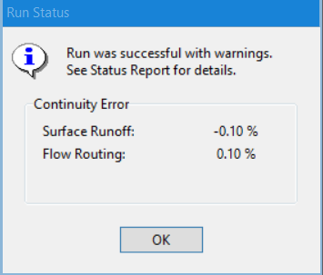
To run the software, we can select the lightning bolt or select Project in the Main Menu and Run Simulation. A Run Status box will appear with information about the run. In this case, we see that the run was successful with a Surface Runoff Continuity Error of -0.10 % and Flow Routing Continuity Error of 0.10%. Additional information is provided in the Project Main Menu under Report and Status Report. A summary of link flow data is shown in the Summary Results shown below.
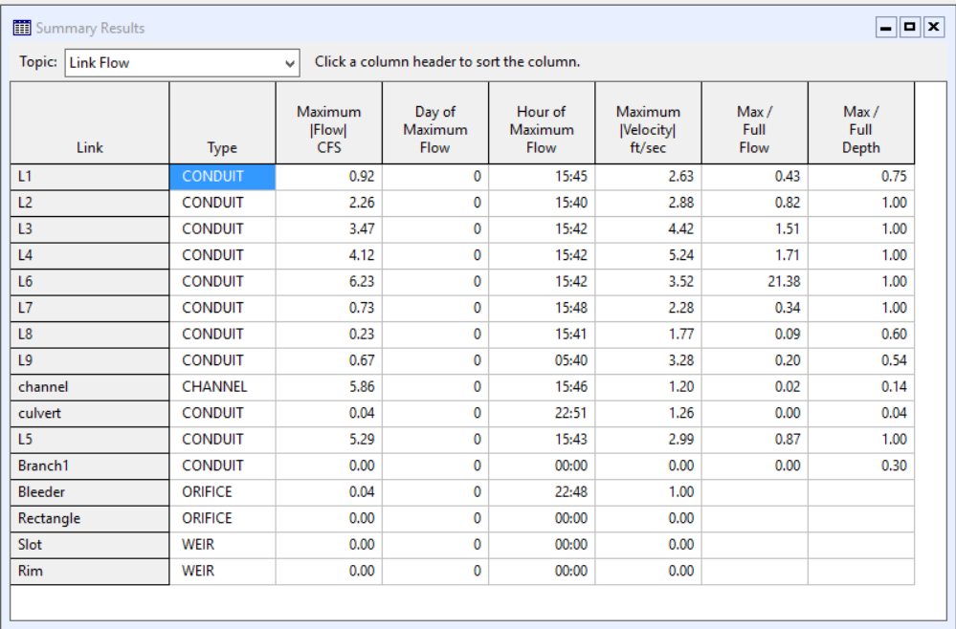
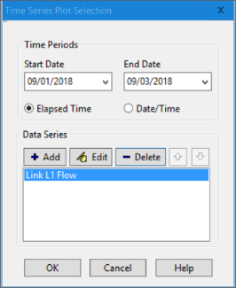
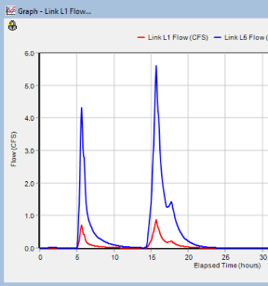
Users can also look at graphs of individual or multiple subcatchments by selecting the Create a time series button or the Graph Time Series under the Report in the Project Main Menu. Select the L1 conduit and click on the time series button. Then the Time Sewers Plot Selection Dialog Box will appear as shown to the right. The user can add a second conduit to display. Let’s add conduit L5 by clicking on the +Add button and selecting L5 and then select the Accept button. Both the L1 and the L5 flow graphs will be shown.
SWMM can also display a profile plot by clicking on the Create a profile plot button  or selecting the Report on the Main Menu and then Graph and Profile. Select the Start Node of MH1 and the End Node of Outfall and then the find Path button. We can run the profile by using the Map in the Project/Map Browser. The animator allows users to watch the routing. The results are shown below. SWMM can also calculate statistics and show scatterplots. These will be discussed in an advanced example.
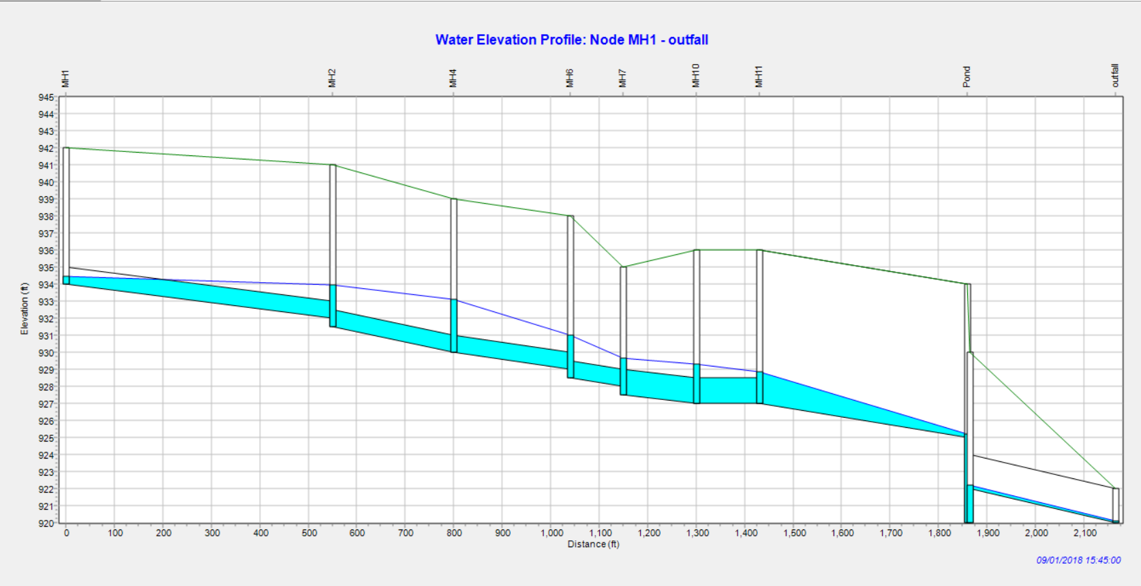
In class we will look at results from various links, subcatchments and links.
Modifying Outlet Structure
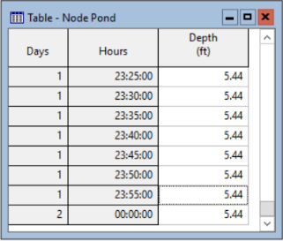
Let’s modify the Outlet Structure to return the Pond to an elevation of 620.2 within 48 hours of the ending time of the rainfall of 17:40 of day 1. The original design with a 0.126-foot diameter orifice results in the pond depth of 620.44 after 48 hours after the run start time. We will need to extend the run time to be at least 2 days and 18 hours. Click on Options in the Project/Map Brower and select Dates where we will change the End Analysis Time to 9/4/2018 18:00. Then we will change the Bleeder to 0.25-foot diameter orifice and then rerun the model. Note that no changes in the Continuity Errors. Then we will look at the results for Pond. Looking at the Table for Pond at the end of the run, the depth in the table to the right is lowered to 620.32, but not down to 620.0. Let’s make the Bleeder orifice to 0.50. The results show that this meets our design requirement as shown below.

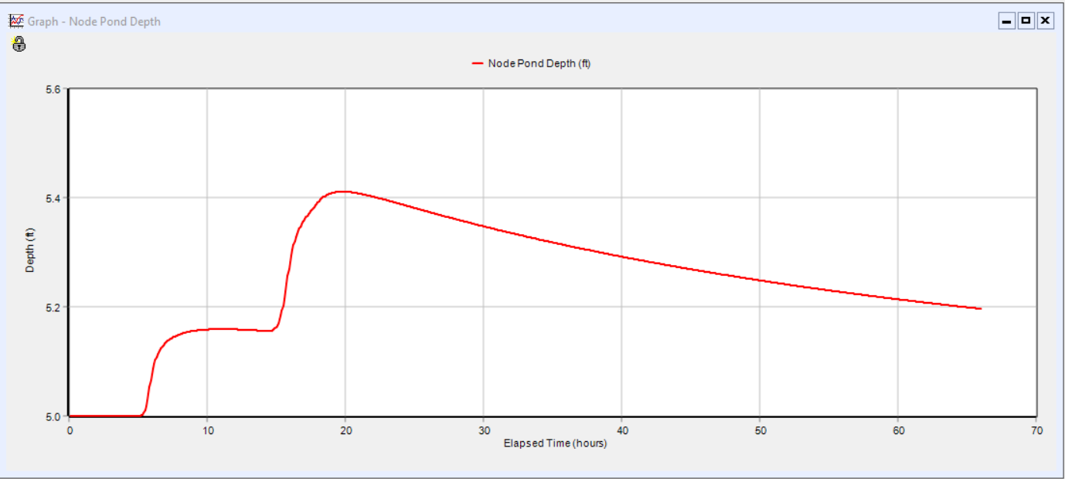
Additional Model Review
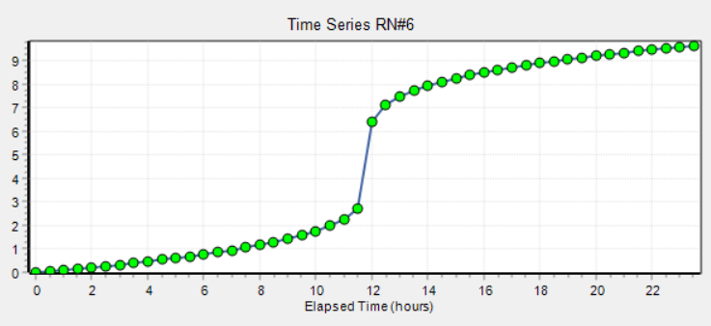
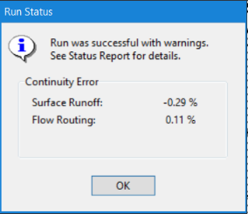
We will change the rainfall to an SCS Type 2 Distribution with a total rainfall of 9.60 inches. In the Project/Map Browser select Hydrology and Rain Gages. Then double click on June18 and change from June 18 to RN#6. Then double click on RN#6 and click on view to see what this rainfall looks like as shown to the right. Let’s run the model and check the results. Clicking on the lighting bolt will run the model. As we can see to the left, the surface runoff continuity has increased to due to the extra rainfall. Let’s look at the peak profile. Click on the Create a profile plot button  or select the Report on the Main Menu and then Graph and Profile. Select the Start Node of MH1 and the End Node of Outfall and then the find Path button. We can run the profile by using the Map in the Project/Map Browser. The animator allows users to watch the routing. The peak results are shown on the following page.

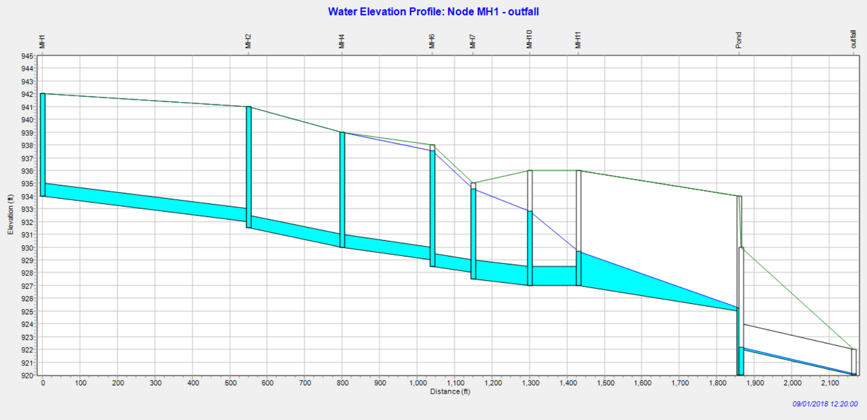
Looking at the above results, we can see that Junctions MH#1, MH#2 and MH#4 are all experiencing flooding. We can also look at the Node Flooding Table shown below. Four nodes are shown to be flooded for up to 0.64 hours (MH#3) during the analysis.
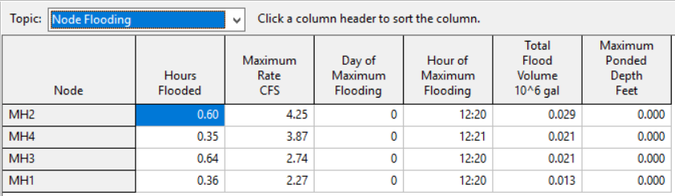
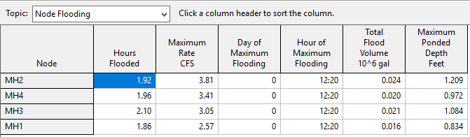
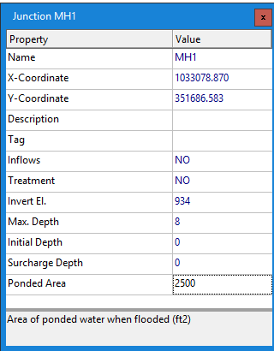
The next step is to add flooding to the routing. This is done by turning on the allow ponding option in the Project/Map Browser General tab under Routing Options. In addition, a ponding area must be set for the four nodes that have flooding. We will assume a 50 foot by 50 foot ponding area or 2500 square feet. Click on each of the four nodes and add 2500 in the ponded area as shown to the right. Then run the model and note that the Flow Routing Continuity went back down to 0.08%. Then look at the node flooding summary table to the right and note that the Maximum Ponded depth now has values and the Hours Flooded increased. The water is being held at each node and then released back into the system rather than overflowing out of the system.
Adding Street Routing or Dual Drainage
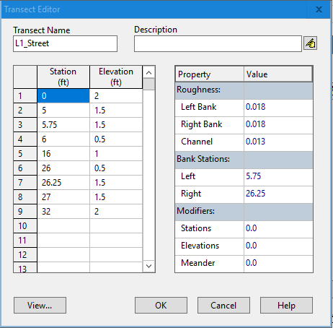
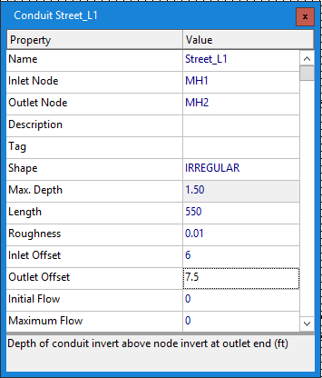

We will now add street routing or sometimes called Dual Drainage. This model allows storm water to flow in both the street and the sewer. If we want to run SWMM in steady flow or Kinematic Wave, we can use the junction type - Flow Dividers. However, if we want to use the Dynamic Wave flow routing flow dividers function as Junction nodes. Since we are using the Dynamic Wave routing and we have node flooding, we can use the use the street to carry the excess flow from Mh#1 to MH#2. Zoom in on the Conduit L1 area and using the add conduit tool draw a new conduit from MH#1 to MH#2 as shown below. Now, we need to add the data for the new street cross-section as show to the right. We need to type in the Name, length, inlet and outlet offsets and then we need to select the shape of the conduit. Double click on the … in the shape box and then select the Irregular. Then click on the edit button next to the empty box under Transect Name. This will open the Transeect Editor where we will type in the data shown to the left. The station data is the feet across the cross-section and the elevation is the vertical elevation. Click on the view button to see what the transect looks like see below.
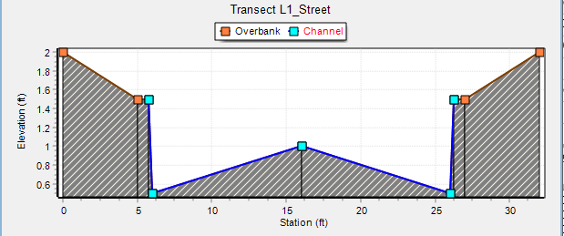
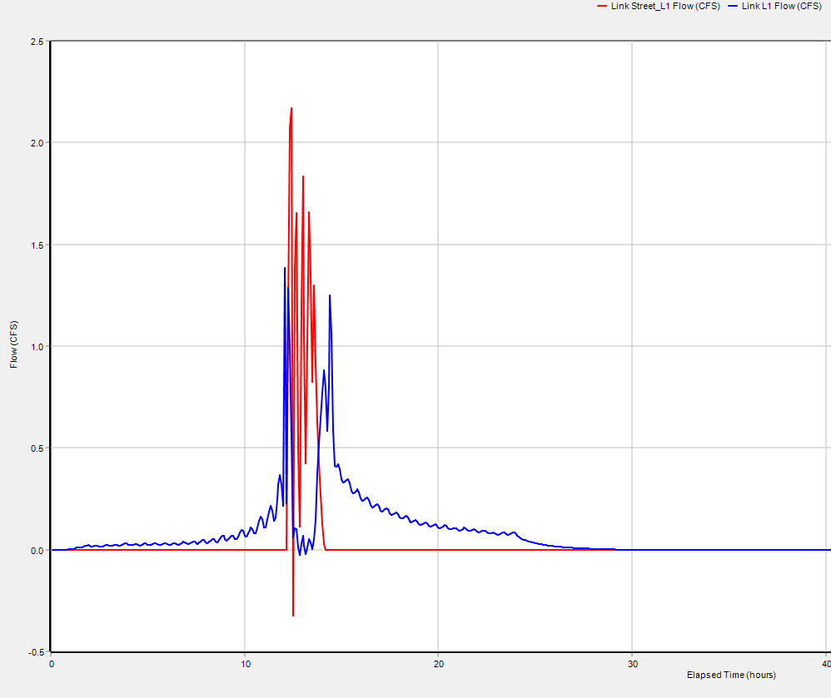
Close the viewer, click on the OK buttons and close the conduit data. Let’s run the model and look at the results. After the run is done. Select the new link and Click on the Create a time series button. Then click on the add button and select the Conduit L1 and accept followed by the OK button. The results are shown to the right. Note that the flow in the pipe (blue) flow goes to near zero cfs when the street flow (red) carries the runoff. We could continue downstream and add additional streets using the same cross-sections or create different cross-sections.

Questions
Using the last file (Hydraulic.inp) we ran:
- What is the peak flow in conduit Channel? _________
- What is the peak elevation in node Pond? ________
- What is the peak runoff from subcatchment MH1#1? ______

